Grace United Church of Christ
Uniontown, Ohio
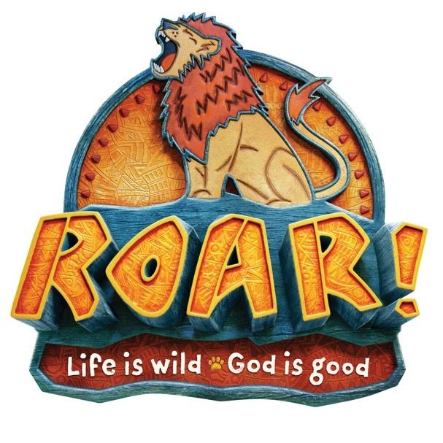
Dear Parents:
Send your kids on a roaring adventure!
At Roar VBS, kids discover that even though life gets wild, God is good. Roar is filled
with incredible Bible-learning experiences kids see, hear, touch, and even taste!
Sciency-Fun Gizmos™, team-building games, cool Bible songs, and tasty treats
are just a few of the standout activities that help faith flow into real life. (Since
everything is hands-on, kids might get a little messy. Be sure to send them in play
clothes and safe shoes.) Plus, we’ll help kids discover how to see evidence of God
in everyday life—something we call God Sightings®. Get ready to hear that phrase
a lot!

Your kids will also participate in a hands-on mission project, through a program
called Operation Kid-to-Kid™, that will provide nutrition and good health
opportunities to moms and babies in Zambia, Africa.

Parents, grandparents, and friends are invited to join us at Safari Celebration each
day at 11:25, a daily exploration of our God’s goodness!
So mark these dates on your calendar: July 22 - 26.
The fun starts at 9:00 and will end at 11:40 .
Complete the attached form to register your children for this life-changing adventure or
go to the Grace web site - www.gracetown.com to register your child.

Sincerely,

Your Roar VBS Director

